“CHESSMOOD”
INTERNATIONAL OPEN CHESS TOURNAMENT
REGULATIONS
Tsaghkadzor, Armenia, 4-12 October, 2021

Chess Academy of Armenia in cooperation with Armenian Chess Federation is organizing “ChessMood” International Open Chess Tournament from October 4 /arrival/ to October 12 /departure/, 2021 at a 5 stars Tsaghkadzor Marriott Hotel, Tsaghkadzor, RA.
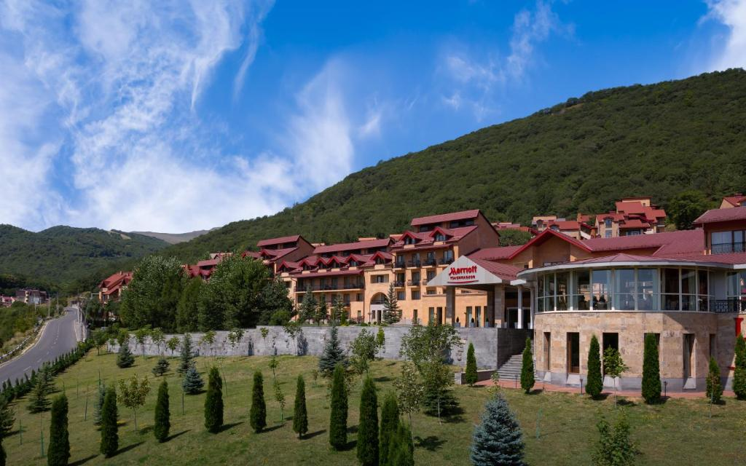
Participation:
The tournament will be held in A and B Groups.
A tournament is open to players with FIDE rating above 2000.
B tournament is open to players with FIDE rating below 2000 and unrated players.

Prizes:
Total prize fund of the tournament is 10 250 000 Armenian drams (490 AMD ≈ 1 USD).

A tournament | I | II | III | IV | V | VI | VII | VIII | IX | X
Main | 2500000 | 1750000 | 1250000 | 750000 | 500000 | 350000 | 250000 | 200000 | 150000 | 150000
U2400 | 175000
U2200 | 125000
Senior 50+ | 150000
Women | 175000 | 125000
Under 18 | 150000

B tournament | I | II | III | IV | V | VI | VII | VIII
Main | 400000 | 250000 | 200000 | 150000 | 100000 | 100000 | 50000 | 50000
Under 14 | 50000
Under 10 | 50000
Women | 50000
Senior 50+ | 50000

Tie-Breaks:
Tie-breaks will be carried out according to the following order:
- Cut Buchholz-1
- Buchholz
- Most black
- Greater number of victories
The monetary prizes will not be shared. No player can receive more than one prize.
Prizes will not be split and will be distributed in accordance with the final standing.
No player can receive more than one prize.
The open tournament will be FIDE rated.
System:
The tournaments will be held in 9-round Swiss system in accordance with FIDE Laws of Chess.
Time control:
A tournament: 90 minutes for the first 40 moves, plus 30 minutes till the end of the game with 30 seconds increment starting from move one.
B tournament: 90 minutes for the whole game with 30 seconds increment starting from move one.
The default time for the tournament is 30 min from the start of the round.

Schedule:
Event | A tournament | B tournament
Arrival | October 4 | October 4
Deadline of mandatory confirmation of participation | October 4, 13:00 | October 4, 13:00
Opening ceremony | October 4, 14:30 | October 4, 14:30
Round 1 | October 4, 15:00 | October 4, 15:00
Round 2 | October 5, 15:00 | October 5, 15:00
Round 3 | October 6, 15:00 | October 6, 15:00
Round 4 | October 7, 15:00 | October 7, 15:00
Round 5 | October 8, 15:00 | October 8, 15:00
Round 6 | October 9, 15:00 | October 9, 15:00
Round 7 | October 10, 15:00 | October 10, 15:00
Round 8 | October 11, 15:00 | October 11, 15:00
Round 9 | October 12, 10:30 | October 12, 10:30
Closing ceremony | October 12, 17:00 | October 12, 17:00

Entry fees:

A tournament |  | Amount
GM, WGM |  | Free of charge
Above 2450 |  | Free of charge
2301-2450 | IM, WIM | 10 000
 | FM | 15 000
 | Untitled | 20 000
2201-2300 | IM, WIM | 15 000
 | FM | 20 000
 | Untitled | 25 000
2001-2200 | IM, WIM | 20 000
 | FM | 25 000
 | Untitled | 35 000
B tournament |  | Amount
1801-2000 |  | 15 000
Under 1800 |  | 20 000
Unrated |  | 25 000

* Students of the Chess Academy of Armenia will receive 20% discount on entry fees.
* Personal transfer for players from the airport to Tsaghkadzor is 8000 AMD per person.

Registration: The deadline is September 25, 2021.

Accommodation
The organizer has provided special conditions for players with a rating of over 2600 rating points. The number of these places is limited!
Hotels recommended by the organizers:

Hotel | Room type | Price with breakfast per person* | Price with full board per person*
Elegant | Single | 20 000 | Those who choose to stay at Elegant Hotel can have lunch and dinner /4000 AMD for each per person/ in the restaurant of Elegant
 | Double | 11 500
University Hotel Tsaghkadzor | Single |  | 8 000
 | Double |  | 8 000
 | Under-12 |  | 6 000
Alpina | Single | - | 12 000
 | Double | - | 10 000
 | Triple | - | 9 000
 | Cottage / 8 person | - | 8 000
Writer’s House | Standard / single | - | 8 000
 | Standard / double | - | 7 000

*All hotel prices are in Armenian Drams (490AMD ≈ 1USD)
* Prices quoted are per person, per night. Number of rooms is strictly limited.
Epidemiological protection
According to the measures that will be valid on Armenia's territory at that moment, the epidemiological safety of participants and officials will be carried out at the tournament.

Entry fees and accommodation costs must be paid to the following Bank account of the Chess Academy:

INTERMEDIARY BANK CITIBANK NA, NEW YORK
SWIFT: CITIUS33
BENEFICIARY’S BANK NAME: AMERIABANK
SWIFT: ARMIAM22
BENEFICIARY NAME: Chess Academy of Armenia Fund
ACCOUNT NUMBER: 1570018417800100
TIN: 02560522

Tournament office:
Chess Academy of Armenia
Address: 34 Shevchenko, 0050, Yerevan, RA
E-mail: chessacademyarm@gmail.com
Tel.: +374 10 44 84 79 /76/

Tournament director:
GM Smbat Lputian

